Odoo – Product Variants

Contents

What is a Product Variant? 1

Impact of variants 1

When should you use variants? 1

When should you avoid using variants? 2

Creating Product Variants 2

Setting Variant Pricing 2

# What is a Product Variant?

Product variants are used to manage products having different variations, like size, color, etc. It allows managing the product at the template level (for all variations) and at the variant level (specific attributes).

As an example, a company selling ethernet cables may have the following product:

CAT 6e Ethernet Cable

* Length: 1ft, 3ft, 6ft, 10ft, 25ft, 50ft
* Colors: Blue, Red, White, Black

In this example, CAT 6e Ethernet Cable is called the product template and CAT 6e Ethernet Cable 3ft, Blue is a variant with length and color as attributes.

The above example has a total of 24 different products (6 sizes x 4 colors). Each one of these products has its own inventory, sales, etc.

# Impact of variants

Since variants are part of a product template, some configurations of the product are controlled by the master product while others are managed directly on the variant.

* **Barcode**: the code and barcode are associated to a variant, not the template. Every variant may have its own barcode / SKU.
* **Price**: every product variant has its own public price that is computed based on the template price ($20) with an optional extra for every variant (+$3 for color red). However, you can define pricelist rules that apply on the template or the variant.
* **Inventory**: the inventory is managed by product variant. You don't own t-shirts, you only own "T-shirts, S, Red", or "T-Shirts, M, Blue". For information purpose, on the product template form, you get the inventory that is the sum of every variant. (but the actual inventory is computed by variant)
* **Picture**: the picture is related to the variant; every variation of a product may have its own primary picture.
* **Other fields**: most of the other fields belongs to the product template. If you update them, it updates automatically all the variants. (example: Income Account, Taxes)

# When should you use variants?

Using variants has the following impacts:

* **eCommerce**: in your online shop, the customer will only see product templates in the catalog page. Once the visitor clicks on such a product, he will have options to choose amongst the variants (colors, sizes, …)
* **Sales Order**: Product variants allow a salesperson to configure a product on sales orders.
* **Manufacturing**: Using variants allows to define only one bill of material for a product template and slight variations for some of the variants. Example: instead of creating a Bill of Material for "T-shirt, Red, S", you create a bill of material for "T-shirt" and add some lines that are specific to the dimension S, and other lines specific to the color Red.
* **Pricing**: The default price of a product is computed using the price of the product template and add the optional extra price on each dimension of the variant. This way, variant prices are easier to maintain since you don't have to set the price for every variant. However, it's possible to create pricelist rules to fix price per variants too.

# When should you avoid using variants?

Using variants may add a level of complexity on the way you use Odoo. You should consider using variants only if you need it to reduce the complexity of managing lots of products that are similar.

# Creating Product Variants

When you create a product, you can easily create variants by going to the Variants tab. Adding an Attribute and Attribute values directly as line items is all you need to do to initially create your variants.

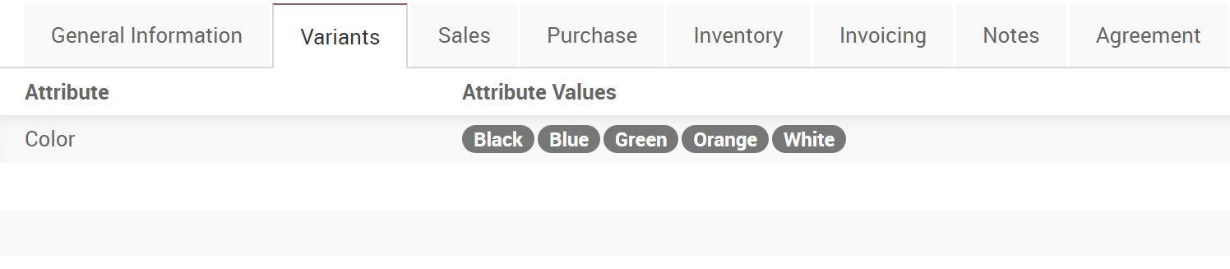

Once you create variants, you can edit them individually to add their own image, barcode, etc. by clicking the Variants smart button on the product template.

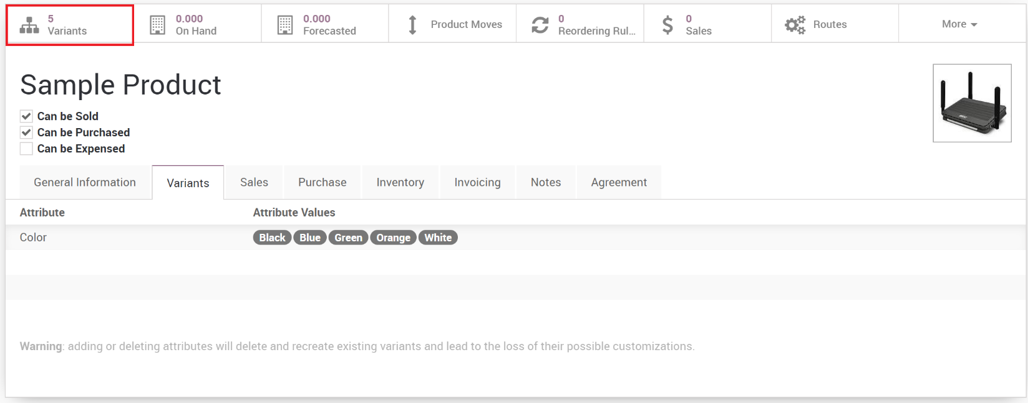

# Setting Variant Pricing

The product variants can have their own costs, but pricing is based on the variant’s attribute and is set on the attribute and not the product. For example, in our above example, the length determines the price so although the base selling price on the product template might be $5.00, 3 ft cables could add $1.00, 5ft adds $2.00 and so on. This allows each attribute to have its own additional price, and the end product variant has a calculated price depending on it’s attributes.

To set the variant pricing:

1. Open the product template.
2. Click the **Variant Prices** button.

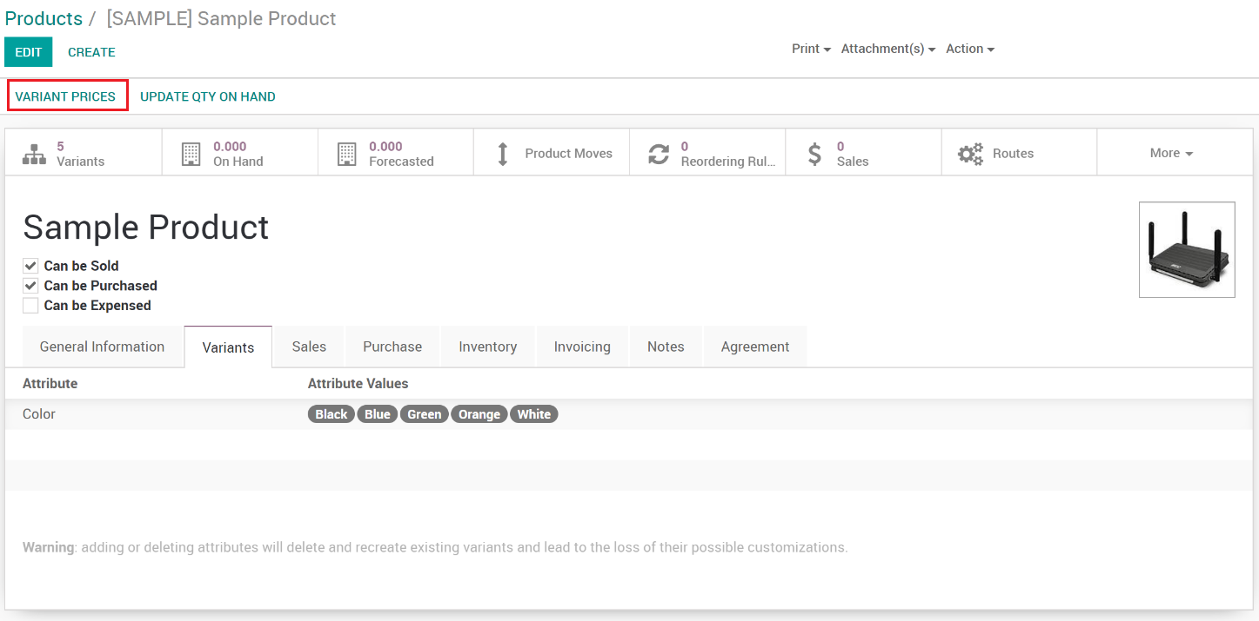

1. The list of variant attributes is shown where you can adjust the additional pricing.

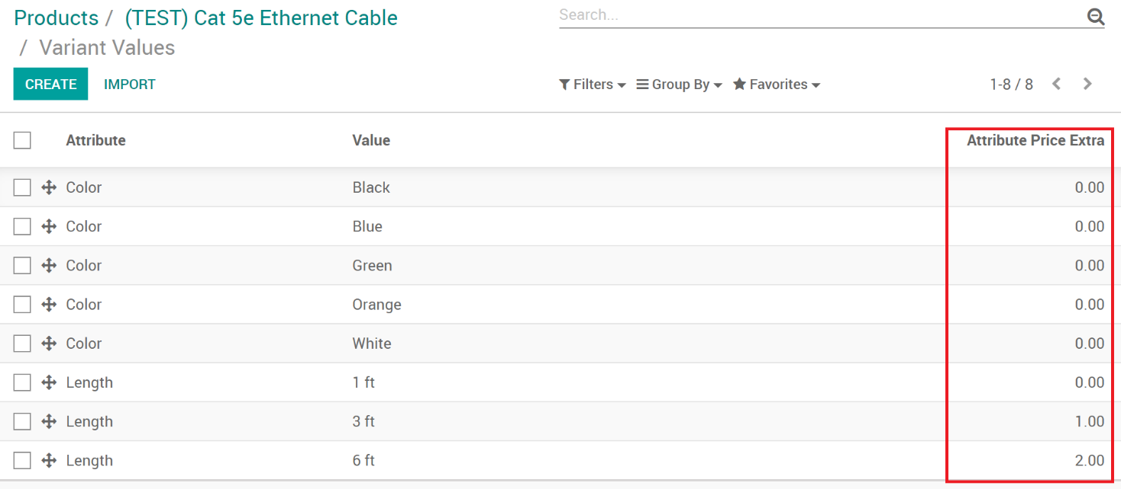

1. Once the pricing is set on the attributes, it will be reflected on the products.

**IMPORTANT**: This is only setting the default price on the products. Pricelists can still override the pricing on each product variant.